**AIDI-2004: Artificial Intelligence in Enterprise Systems**

**Lab #1 – Git, GitHub, GitLab**

**Sahil Khan**

**100942935**

Step 1:

Install git in your local machine

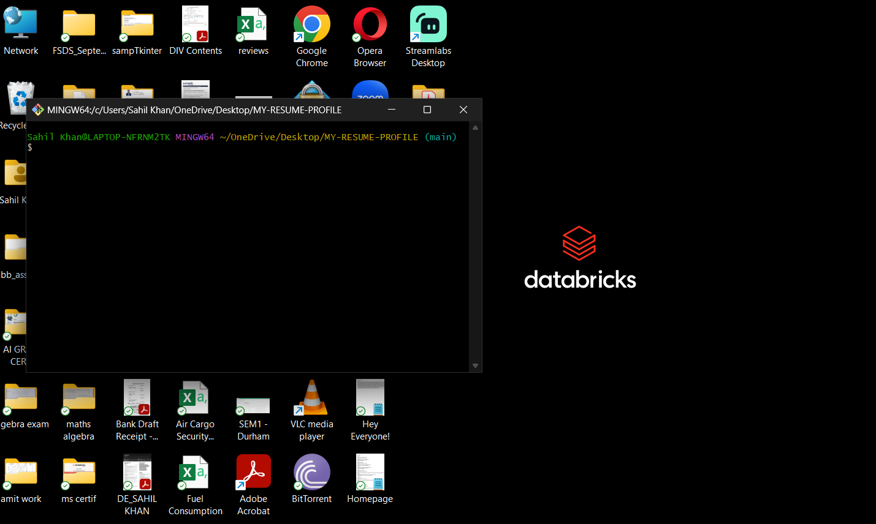

Step 2:

Create user accounts in both github and gitlab

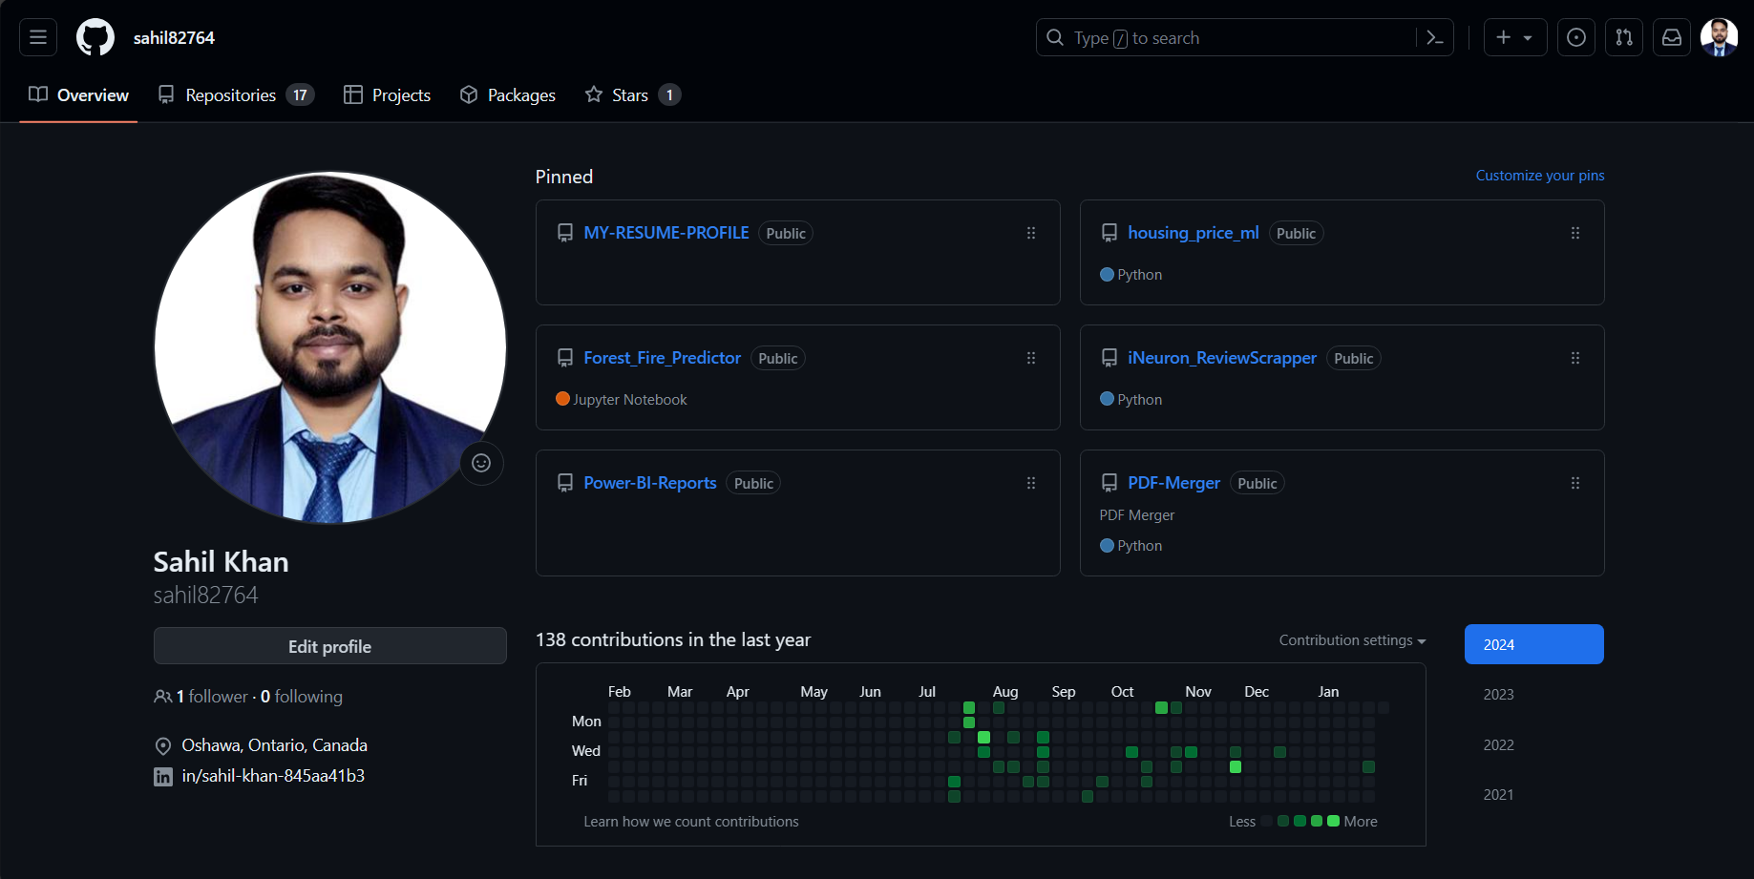

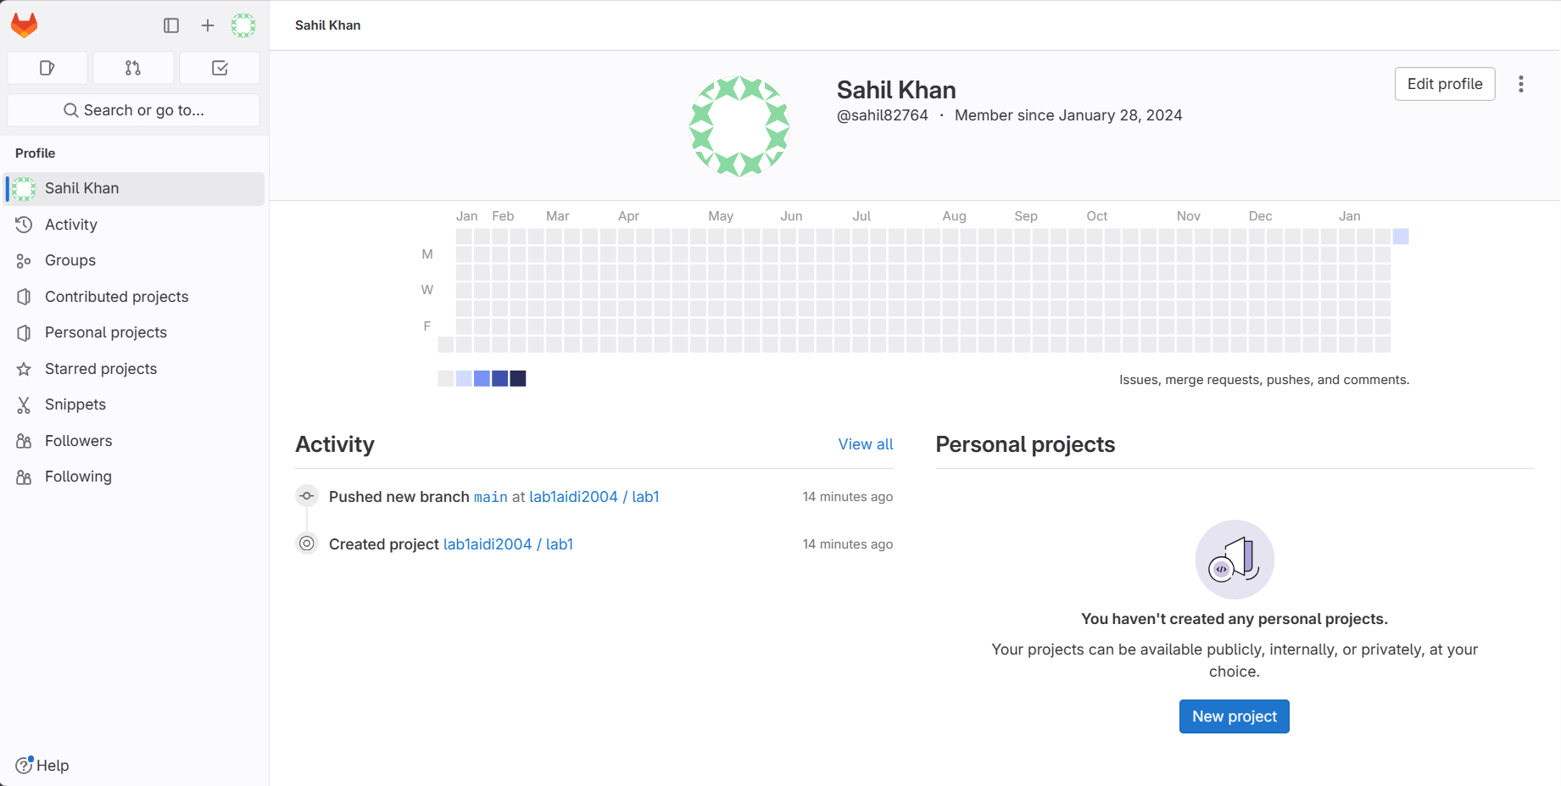

Step 3: Marks: 10

Review github and gitlab. Select your remote host (github or gitlab or any new one) and justify your selection.

I prefer GitHub over GitLab because of its greater user base, vast ecosystem, and active community. The GitHub Marketplace's seamless connection with third-party services streamlines development workflows. GitHub Actions, a robust CI/CD and automation tool, is notable for its flexibility. The sponsorship program provides financial support for open-source projects, encouraging community participation. The fact that GitHub serves as a primary center for important open-source initiatives contributes to its popularity. Overall, I favor GitHub over GitLab due of its collaborative environment, connection, and support for open-source projects.

Step 4: Marks: 10

Write a basic program performing key programming activities

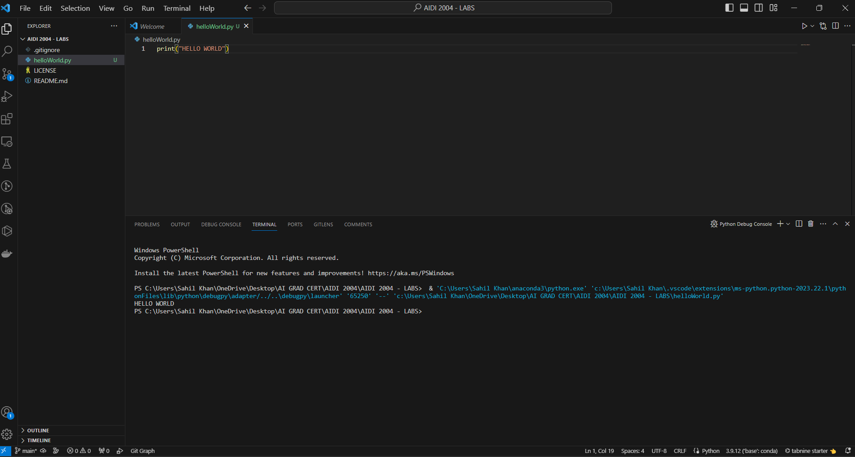

Step 5: Marks: 10

Provide screenshot of your command prompt showing success of your commit in the remote host.

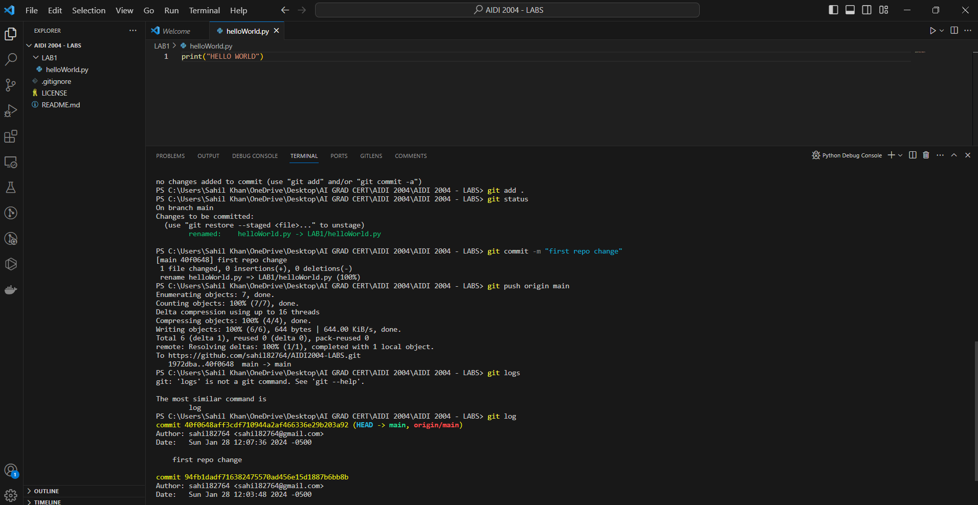

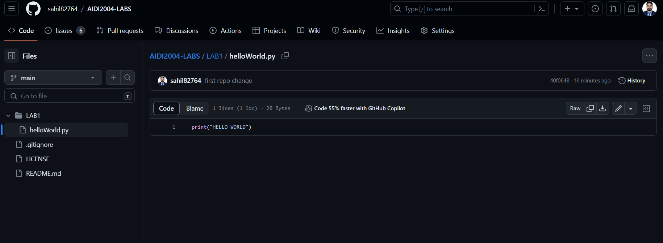

Step 6: Marks: 10

Provide a description of your program in the readme.md file

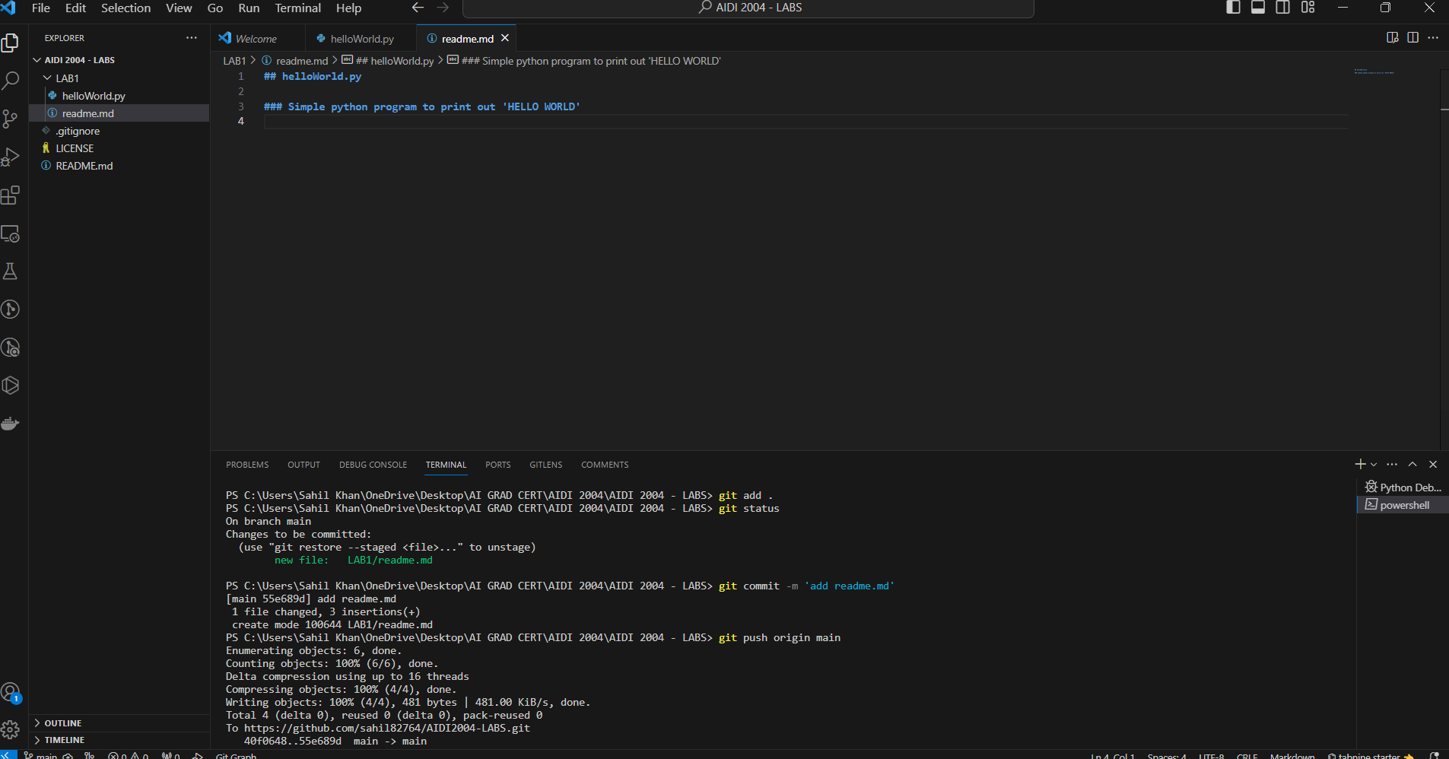

Step 7: Marks: 10

Create a branch in your repo and upload any python script in that branch

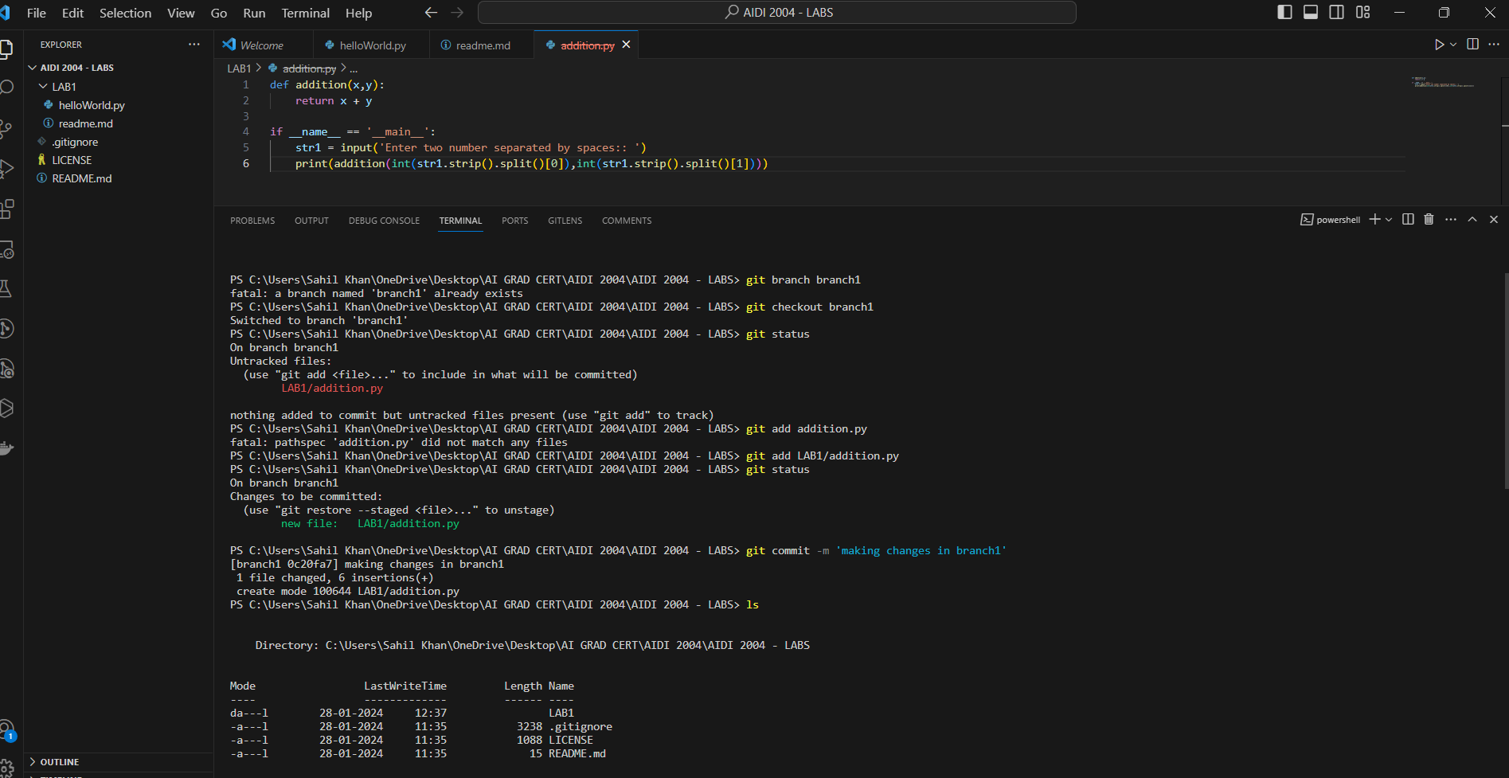

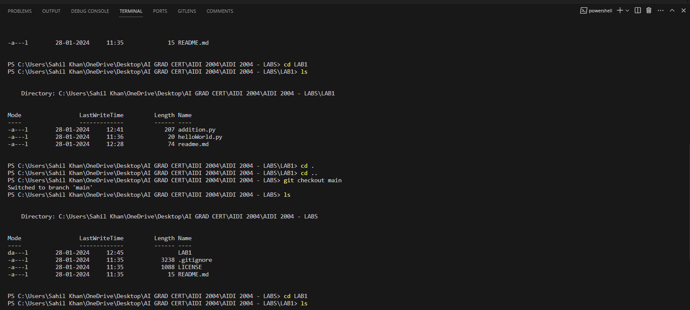

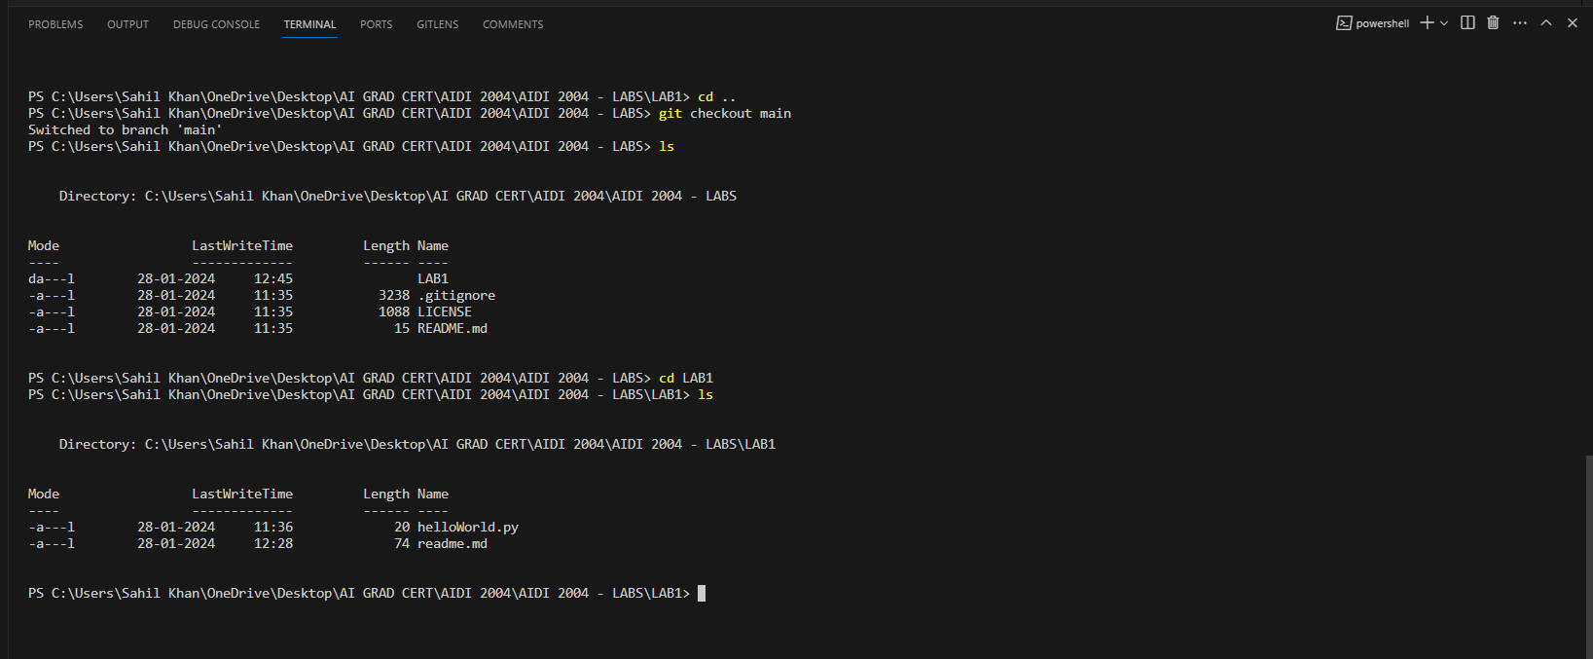

Step 8: Marks: 10

Navigate to your newly created branch and provide screenshot showing status of your repo

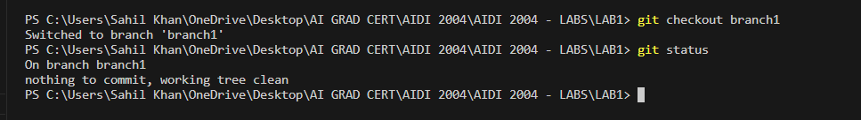

Step 9: Marks: 10

Provide a screenshot showing your log of activities and perform your final commit

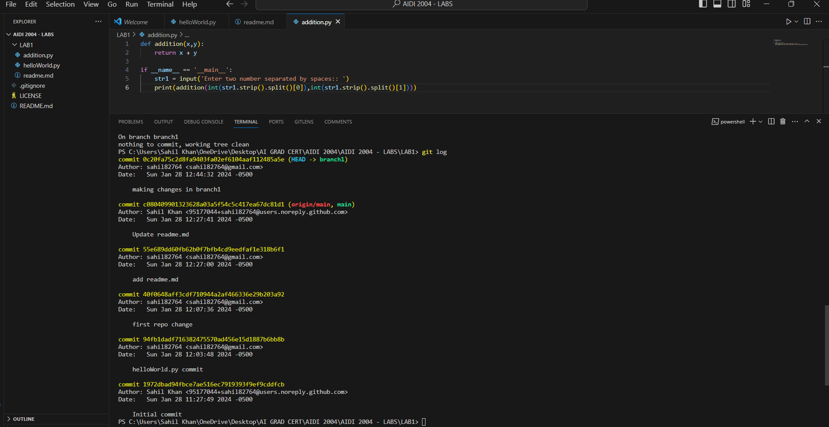

MERGING BRANCHES:

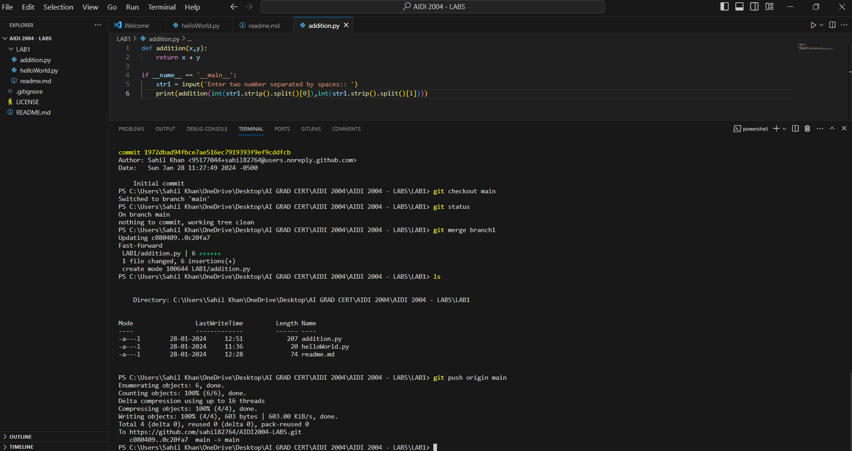

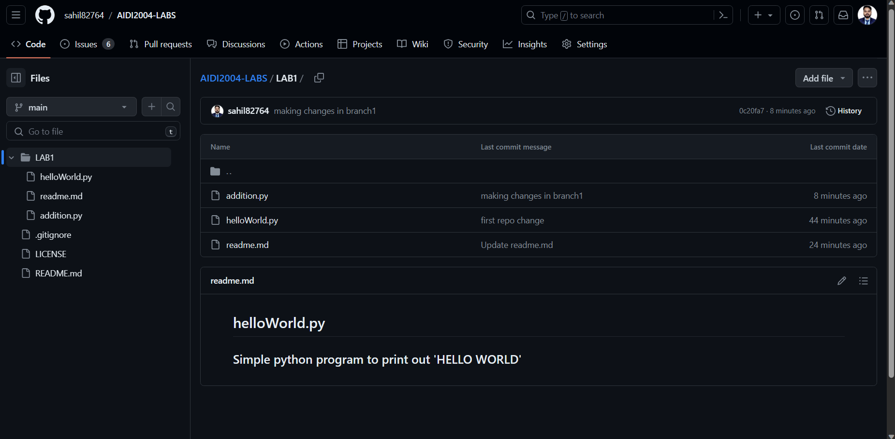

Step 10: Marks: 10

Make your repo public and share the link of your repo for check.

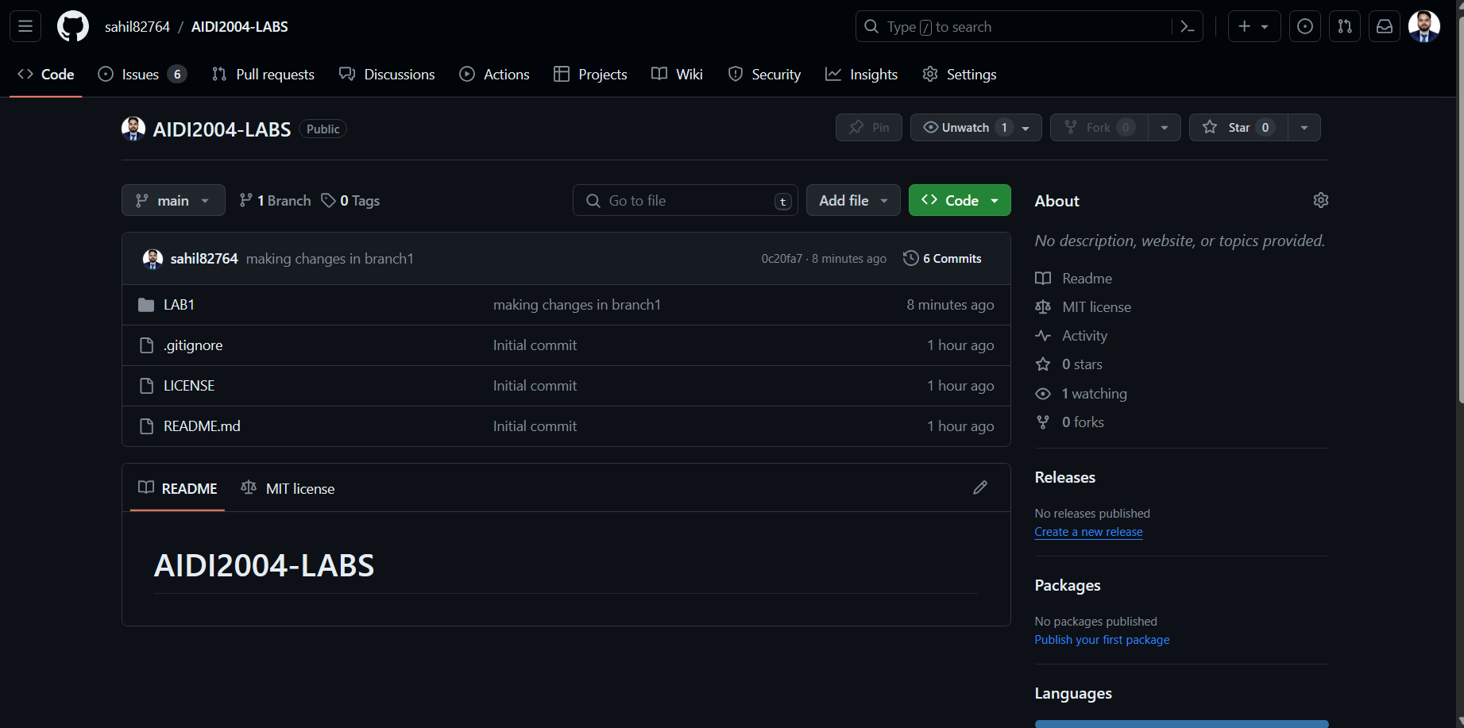

<https://github.com/sahil82764/AIDI2004-LABS.git>